Data Science Assignment 1

Name: Abhishek Kumar Shukla
Roll number: 187203
Section: B
1. Read, modify, and print the elements of lists, tuples, sets and dictionaries. Find out the differences among them.

CODE:
# Q1
def print_type(type__):
if type(type__) is set:
print("set now: ")
elif type(type__) is tuple:
print("tuple now: ")
elif type(type__) is dict:
print("dictionary now: ")
elif type(type__) is list:
print("list now: ")
print(type__)
myList = [1, 2, 3, 4, 5, 6]
myTuple = ("a", "bcd", 1, 2)
myDict = {
1: "Hello",
2: "World",
3: "!!!",
4: "How are",
5: "You?",
}
mySet = {"apple", "orange", 1, 2, 2, "apple"}
print("The list is:")
print(myList)
print("The tuple is:")
print(myTuple)
print("The dictionary is:")
print(myDict)
print("The set is:")
print(mySet)
# SET OPERATIONS
mySet.add("banana")
mySet.add(True)
print_type(mySet)
mySet.remove("apple")
print_type(mySet)
# DICTIONARY OPERATIONS
myDict[5] = "Hola"
print_type(myDict)
myDict[6] = "I am fine, thankYou"
print_type(myDict)
myDict.pop(3)
print_type(myDict)
# LIST OPERATIONS
myList.append(23)
print_type(myList)
myList[6] = "Hello"
print_type(myList)
myList.remove(3)
print_type(myList)
# TUPLE OPERATIONS
(val1, val2, val3, val4) = myTuple
print("After unpacking tuple: ")
print(val1, val2, val3, val4)

OUTPUT:
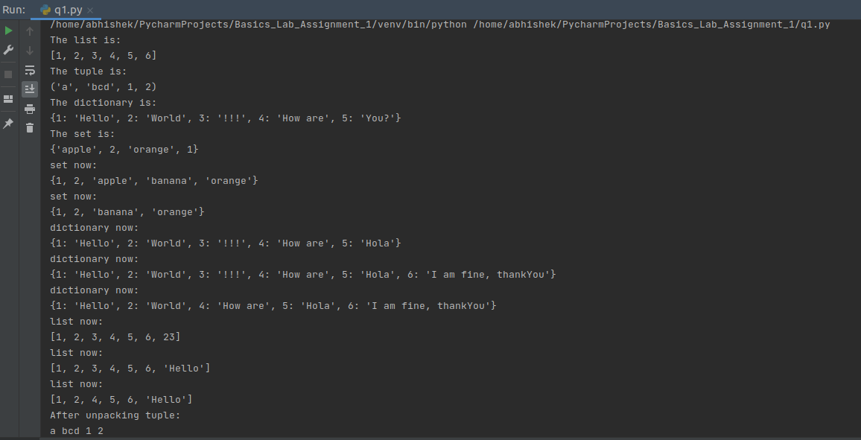

2. Given a list lst1=[1,2,3,4,5]. Write a program to copy the list lst1 to another list lst2, and then multiply each element in lst2 with 2. Print lst1 and lst2. (Answer should be lst1=[1,2,3,4,5] and lst2=[2,4,6,8,10])

CODE:
# Q2
lst1 = [1, 2, 3, 4, 5]
lst2 = lst1.copy()
for i in range(len(lst2)):
lst2[i] = 2 * lst2[i]
print(lst1)
print(lst2)
OUTPUT:
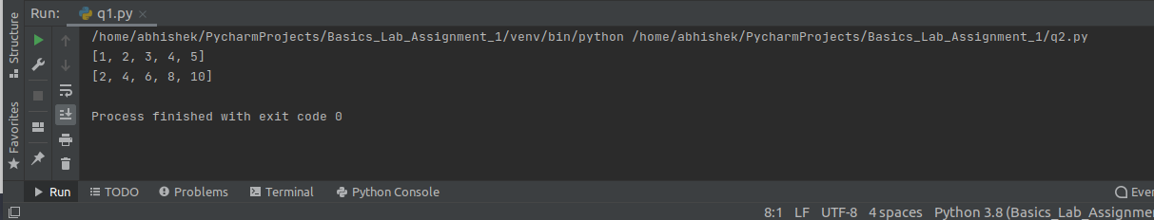

3. Write a python program to find a largest and smallest element in a given list. Suppose list contains the numbers [5,2,8,9,15,3,22,7].

CODE:

# Q3
lst = [5, 2, 8, 9, 15, 3, 22, 7]
print("smallest value: ", min(lst))
print("largest value: ", max(lst))
OUTPUT:
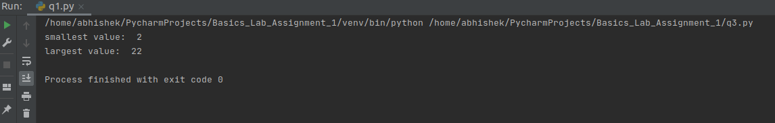
4. Write a python program to print prime numbers in a given range. Suppose given range is 10 to 20, the answer would be 11,13,17,19.

CODE:

# Q4
def sieve(m, n):
prime = [True for i in range(n + 1)]
p = 2
while p * p <= n:
if prime[p]:
for i in range(p * p, n + 1, p):
prime[i] = False
p += 1
for p in range(m, n + 1):
if prime[p]:
print(p)
if __name__ == '__main__':
m = 10
n = 20
print("Prime numbers in range (", m, ", ", n, ") are:")
sieve(m, n)
OUTPUT:
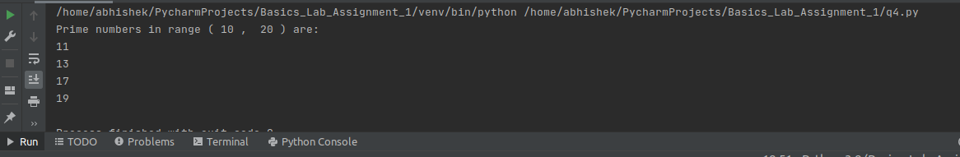

5. Write a python program to find lcm and gcd of any two given numbers.

CODE:
# Q5
def gcd(a, b):
if b == 0:
return a
if a == 1 or b == 1:
return 1
if a <= b:
return gcd(a, b % a)
return gcd(b, a % b)
def lcm(a, b):
return int((a * b) / gcd(a, b))
x = int(input())
y = int(input())
print("GCD is: ", gcd(x, y))
print("LCM is: ", lcm(x, y))
OUTPUT:
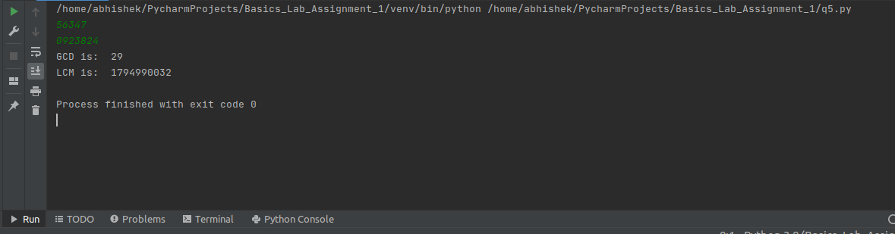

6. Write a program to read an english sentence and count the frequency of occurance of each alphabet in the sentence.
For example given a sentence : Rama is a good boy.
Output: a:3, b:1, d:1, g:1, i:1, m:1, o:3, r:1, s:1, y:1

CODE:
# Q6
print("Enter string: ")
string = input()
str__ = string.lower()
myDict = {}
for i in str__:
if i in myDict:
myDict[i] += 1
else:
myDict[i] = 1
print("Following is the count:")
print(myDict)
OUTPUT:
